Design: VSDL Download

Overview

Current processing
Currently Post Data Server (PDS) gets Valid Series Download from TPF .

New requirement
Post TPF migration; download between CBOEDirect and PDS needs to incorporate the following additional information.
- For each class
- Reporting Class Symbol
- Post
- Station
- Underlying type
- Multilist
- Perm break
- Fraction type
- Display format
- Low tick
- High tick
- Product State Indicator
- For each series
- Close
- Close suffix.

List of affected components and systems affected
- IPD (Interface structure from IPD to CBOEDirect needs to be changed for “Multilist “data).
- CBOEDirect (Database changes for storing ‘Multilist’ in GC and MDGC)
- PDS (MDBAdapter connection to SBT)

Scope
- IPD (Interface structure from IPD to CBOEDirect will be modified to include “Multilist “data).
- IPD Industrial Product Maintenance Service and Industrial ProductQuery Service will be modified to include multilist in CBOEDirect.
- IPD resync script will be modified to include multilist.
- CBOEDirect (Database changes for storing ‘Multilist’ in GC and MDGC)
- CBOEDirect Product Maintenance Service and ProductQueryService will be modified to include multilist data
- PDS (MDBAdapter connection to SBT) will be modified to add and format class information such as post,station etc along with settlement price,settlement suffix and multilist indicator.
- Derived cache will be modified to incorporate the Product Class and settlement information.

Assumptions
In IPD Product Class , Reporting Class and Product are added sequentially.
There will no chages to MDB Brodcasting process flow.All changes are applicable to VSDL query from PDS to CBOE.

Implementation
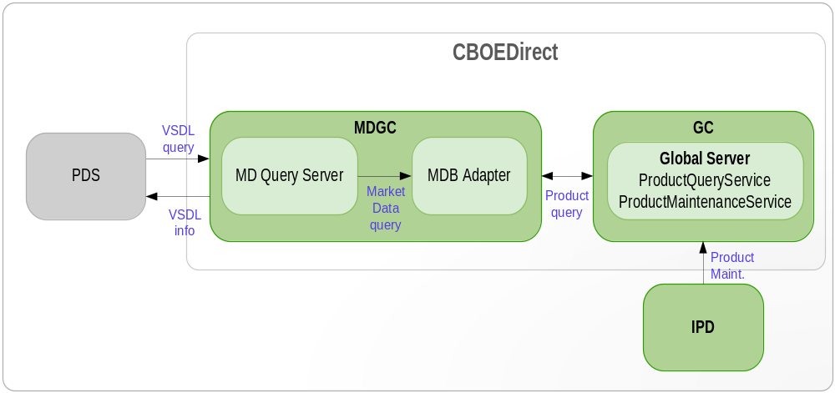

Process Flow:
IPD to CBOEDirect:
- IPD updates the product class and series data on CBOEDirect through the product maintenance service at End of Day and Intra day.
- IPD will be modified to send the addition field multilist to CBOEDirect only during the transmission.
- ProductMaintenanceService in CBOEDirect will be changed to incorporate the additional field “multilist” coming from IPD.
  - The method addProductClassWithKeyV3(ClassDefinitionStructV3 newClass) will add the ClassInformation along with “multilist”.
  - The method updateProductClassWithKeyV3(ClassDefinItionStructV3 newClass) of ProductMaintenanceServiceImpl.java will be responsible for updating multilist field. This field ‘multilist’ will be set in ProductClassStructV3.
- Whenever there is call on IPD to CBOEDirect for addition or updation of Reporting class then the ProductClass Information will be modified in CBOEDirect to set the multilist flag by calling step no 3 b.
- Whenever the reporting classes are inactivated the multilist flag of the product class in CBOEDirect will be updated accordingly.
- StructConverter.java will be modified to convert IndustrialProductClassStruct to ClassDefinitionStructV3.
- Resync.java in IPD will be modified to compare additional field multilist and the difference is logged.

CBOEDirect to PDS Flow:
- PDS serially downloads the class/series data from CBOEDirect before beginning of day around 02.00.00.
- PDS can get download from CBOEDirect as and when required, as it's a manual process. PDS also requires series related data for any new series created intra day by Window team
- Derived Cache will be modified to cache the class information along with settlement price,settlement suffix and multilist indicator by querying the ProductQueryServiceImpl
- MDBAdaptor will be modified to return the MarketDataResponseStruct[] with values set as spaces for closingPrice, closingSuffix for the reporting class.MDQSever will get the values of closingPrice,closingSuffix from the cache maintained for the closing price and closing suffix and update into to MarketDataResponseStruct for corresponding product.
- Modify MDQStartMessageHolder.java to send class level details like Reporting Class Symbol, Post, Station, Underlying type, Multilist,Perm break,Fraction type,Display format,Low tick,High tick in the Header section of the message sent to PDS.
- Modify the MDQResponseMessageHolder.java to incorporate close price, close suffix and price format.
- The format of the report to pds will be as shown in the attached excel sheet.
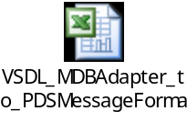
- IPD to CBOEDirect Flow:
Addition of Product Class: 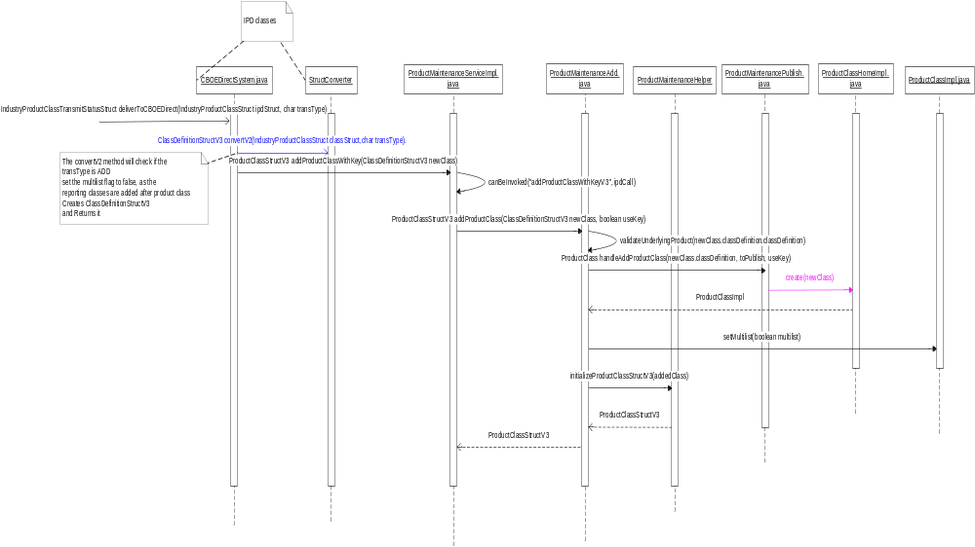
Updation of Product class:
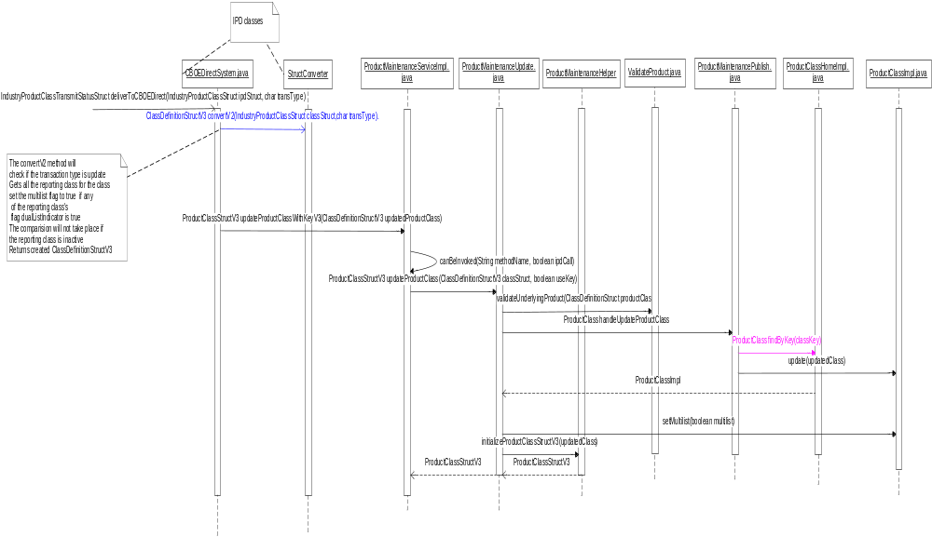

Updation of multilist while creating or updating Reporting class for the Product class:
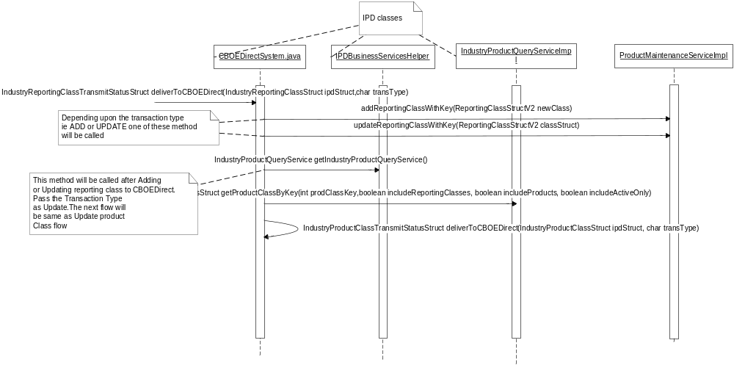

Updation of multilist after inactivation of Reporting Classes:
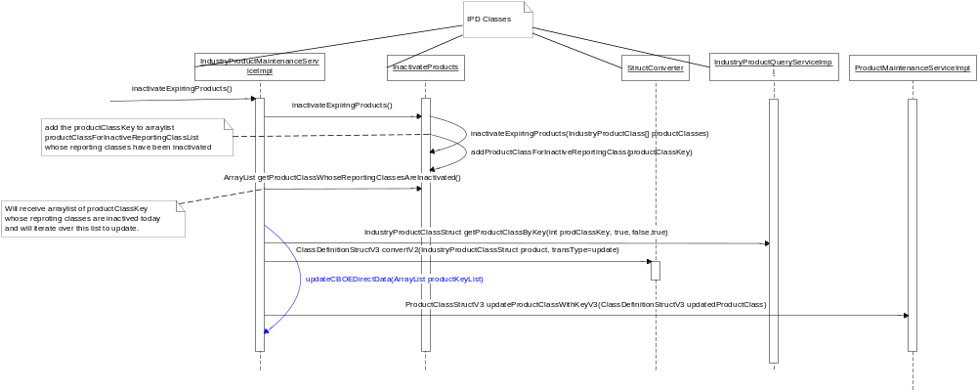
Enhancement of resyncCBOEDirect to compare multilist:
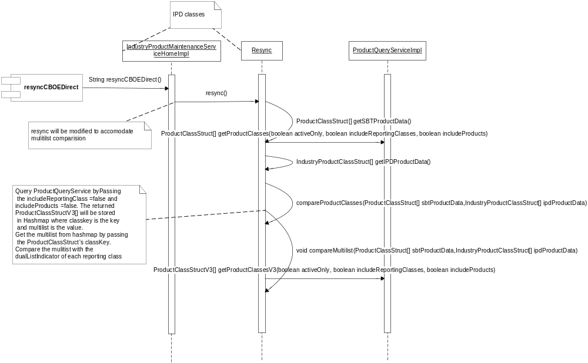

- CBOEDirect to PDS FLOW

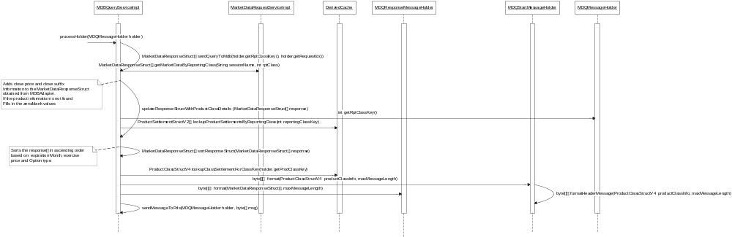
- IDL Changes

IPD to CBOEDirect

CBOEDirect to PDS

  - MarketDataRequestService.idl
Location: \server\idl\MarketDataRequestService.idl
struct MarketDataResponseStruct
{
ProductInfoStruct productInfo;
Price marketBidPrice;
Price marketAskPrice;
Size marketBidSize;
Size marketAskSize;
Price bookBidPrice;
Size bookBidSize;
Price bookAskPrice;
Size bookAskSize;
Size nonCustomerBookBidSize;
Size nonCustomerBookAskSize;
boolean isBidMarketBest;
boolean isAskMarketBest;
MarketIndicator marketIndicator;
LastSaleSuffix lastSaleSuffix;
Price lastSalePrice;
Price eopPrice;
Size eopSize;
boolean errorFlag;
string bidSideLocation;
string askSideLocation;
Price closingPrice;
string closingSuffix;
};

  - Product.idl
Location: \domain\idl\product.idl
struct ClassSettlementStructV3
{
cmiProduct::ClassKey classKey;
boolean multilist;
string extension;
product::ProductLocationStruct productLocation;
product:: ProductSettlementStructV2Sequence productSettlements;
}

typedef sequence <ClassSettlementStructV3> ClassSettlementStructV3Sequence;

struct ProductClassStructV4
{
product :: ProductClassStruct productClass;
product :: ClassSettlementStructV3 classSettlement;
}
typedef sequence < ProductClassStructV4> ProductClassStructV4Sequence;

  - ProductQueryService.idl
Location: \server\idl\ProductQueryService.idl

product::ProductClassStructV4Sequence
getProductClassesByKeyV4(in cmiProduct::ClassKeySequence productClassKeys,
in boolean includeReportingClasses,
in boolean includeProducts,
in boolean includeActiveOnly)
raises(
exceptions::SystemException,
exceptions::CommunicationException,
exceptions::DataValidationException,
exceptions::AuthorizationException
);

- Interfaces and Classes
  - IPD Changes
    - StructConverter.java
Location: /ipdserver/Java/impls/com/cboe/internalBusinessServices/industryProductMaintenanceService/notifications/cboeDirect/StructConverter.java
      - Define method public static ClassDefinitionStructV3 convertV2(IndustryProductClassStruct in, char transType)
        - Instantiate ClassDefinitionStructV3.
        - Call convert(IndustryProductClassStruct in). This method will convert IndustryProductClassStruct to ClassDefinitionStructV2 and set it to ClassDefinitionStructV3.
        - Set the value default value of multilist as false;
        - If transType equals UPDATE then make a call to method public static boolean identifyMultilistValue(IndustryProductClassStruct in) throws DataValidationException of class MultilistValueIdentifier.java and get the multilist value.
        - Return the ClassDefinitionStructV3.

    - CBOEDirectSystem.java
Location: /ipdserver/Java/impls/com/cboe/internalBusinessServices/industryProductMaintenanceService/dissemination/
      - Modify method private IndustryProductClassTransmitStatusStruct deliverToCBOEDirect(IndustryProductClassStruct ipdStruct, char transType)
        - Call StructConverter.convertV2(ipdStruct). This will return ClassDefinitionStructV3
        - If the transaction Type is ADD call IPDBusinessServicesHelper.getProductMaintenanceService().addProductClassWithKeyV3(ClassDefinitionStructV3)
        - Else calls IPDBusinessServicesHelper.getProductMaintenanceService().updateProductClassWithKeyV3(ClassDefinitionStructV3)
      - Modify IndustryReportingClassTransmitStatusStruct deliverToCBOEDirect(IndustryReportingClassStruct ipdStruct,char transType)
        - The below will be called after the add or update flow of reporting class is compeleted
        - Get IndustryProductQueryService by calling IPDBusinessServicesHelper.getIndustryProductQuerySerive();
        - Call IndustryProductClassStruct getProductClassByKey(int prodClassKey, true, true, true)
        - Call by passing IndustryProductClassStruct to IndustryProductClassTransmitStatusStruct deliverToCBOEDirect(IndustryProductClassStruct ipdStruct, TransactionTypes.UPDATE)

    - InactiveProducts.java
Location: /ipdserver /Java/impls/ com/cboe/internalBusinessServices/ industryProductMaintenanceService
      - Define a member variable private ArrayList productClassForInactiveReportingClassList.
This list will contain the list of product class whose reporting class(es) has been inactivated today.
      - Define method private void addProductClassForInactiveReportingClass(int productClassKey)
This method will add the passed product key to productClassForInactiveReportingClassList.
      - Define method public ArrayList getProductClassWhoseReportingClassesAreInactivated().
This method will return productClassForInactiveReportingClassList
      - Modify private int inactivateExpiringProducts(IndustryProductClass[] productClasses)
        - In the last of for loop of productClasses. Check if rptClassCount is greater than zero, if yes then pass the product class key to addProductClassForInactiveReportingClass(int productClassKey)
    - IndustryProductMaintenanceServiceImpl.java
Location: /ipdserver/Java/impls/com/cboe/internalBusinessServices/industryProductMaintenanceService/
      - Define method private void updateCBOEDirectData(ArrayList productKeyList)
        - Iterate over productKeyList.
        - For each productKey Call getIndustryProductQueryService().getProductClassByKey(int prodClassKey, true, false,true) which retruns IndustryProductClassStruct
        - For each IndustryProductClassStruct call StructConverter.convertV2(ipdStruct, transType=update). This will return ClassDefinitionStructV3
        - Calls ProductClassStructV3 updateProductClassWithKeyV3(ClassDefinitionStructV3 updatedProductClass) on ProductMaintenanceServiceImpl of CBOEDirect.
      - Modify method public void inactivateExpiringProducts()
        - Change the section new InactivateProducts().inactivate() to InactivateProducts inactivateProducts = new InactivateProducts()
          - Call inactivateProducts.inactivate();
          - Call inactivateProducts.getProductClassWhoseReportingClassesAreInactivated() and store the arraylist in productKeyList
          - Call updateCBOEDirectData(productKeyList)

    - Resync.java
Location: /ipdserver/Java/impls/com/cboe/internalBusinessServices/industryProductMaintenanceService/resync/cboeDirect/Resync.java
      - Define a Arraylist private final List multilistMismatch. This Arraylist will contain multilist mismatch information.
      - Modify method public synchronized String resync() to clear multilistMismatch Arraylist.
      - Modify compareProductClasses(ProductClassStruct[] sbtProductData, IndustryProductClassStruct[] ipdProductData) to add multilist comparation
        - After the outer for loop call compareMultilist(Boolean multilist, sbtProductData, ipdProductData) by passing the sbtProductData and ipdProductData arrays.
      - Add new method private void compareMultilist( ProductClassStruct[] sbtProductData, IndustryProductClassStruct[] ipdProductData)
          - Create a HashMap sbtProductDataMap having ProductClassStruct as value and productClassKey as the key.
          - Create a HashMap classMultilistMap and get the ProductClassStructV3 by calling method getProductClassMultlistMap which internally queries getProductClassesV3(true,false,false) of ProductQueryService to get the ProductClassStructV3 array.
          - Iterate through the ProductClassStruct[] and put it in sbtProductDataMap.
          - Iterate through IndustryProductClassStruct[] and check that ProductClassStruct is not null and classMultilistMap in not null.
            - If classMultilistMap is not null get boolean multilist value from classMultilistMap.
            - If multilist is true iterate over IndustryProductClassStruct and if listingState is ACTIVE and dualListIndicator is true then set multilistFlag as true.
            - If multilistFlag is still false, then it means that multilist in SBT is true but none of the reportingClass has their dualListIndicator as true and it is a mismatch so add it to multilstMismatch arraylist.
            - If the multilist in SBT is false then check if any of the dual list indicator is true and add to multilistMismatch arraylist.
      - Modify method private String printReport() to add the multilistMismatch information.
      - Define a method private String keyStringMultilist(IndustryProductClassStruct struct, boolean multilist, boolean dualListIndicator)
This method will create a Multilist information string by appending the values of classKey, productType, multilst and dualListIndicator

    - MultilistValueIdentifier.java
      - Define a method public static boolean identifyMultilistValue(IndustryProductClassStruct in)
        - Iterate on IndustryReportingClassStruct array and check if the listing state is ACTIVE and dual has dual list indicator as true then set the multilist value as true.
        - Return the multilst.

  - FE Changes:
    - ProductMaintenanceServiceRoutingProxy.java
Location: /vobs/dte/server/java/proxies/com/cboe/proxy/ internalBusinessServices/ ProductMaintenanceServiceRoutingProxy.java

      - Check whether IndustryProductClassStruct is null and if yes throw dataValidationException
      - Define a method public ProductClassStructV3 addProductClassWithKeyV3(ClassDefinitionStructV3 newClass) throws
SystemException, CommunicationException,
DataValidationException, TransactionFailedException,
AuthorizationException, AlreadyExistsException
        - This method will delegate the request to the addProductClassWithKeyV3(ClassDefinitionStructV3 newClass) method of ProductMaintenanceServiceimpl.java
      - Define a method public ProductClassStructV3 update ProductClassWithKeyV3(ClassDefinitionStructV3 updatedProductClass)
throws SystemException, CommunicationException, DataValidationException, TransactionFailedException, AuthorizationException
        - This method will delegate the request to the updateProductClassWithKeyV3(ClassDefinitionStructV3 updatedProductClass) method of ProductMaintenanceServiceimpl.java

  - ProductMaintenanceService Changes
    - ProductMaintenanceServiceImpl.java
Location: /vobs/dte/server/java/impls/com/cboe/internalBusinessServices/
ProductService/ProductMaintenanceServiceImpl.java
      - Define a method public ProductClassStructV3 addProductClassWithKeyV3(ClassDefinitionStructV3 newClass) throws
throws SystemException, CommunicationException, DataValidationException, TransactionFailedException, AuthorizationException, AlreadyExistsException
This method will have the logic for creating the product class.
        - Check if the call is from IPD by calling canBeInvoked(String methodName, boolean ipdCall).
        - Validates for valid classKey and prodcutType else throws DataValidataionException
        - Calls ProductMaintenanceAdd.addProductClass(newClass, true)
      - Define a method public ProductClassStructV3 updateProductClassWithKeyV3(ClassDefinitionStructV3 classStructV3)
throws SystemException, CommunicationException, DataValidationException, TransactionFailedException, AuthorizationException
        - This method will have the logic for updating the product class by using the information from ClassDefinitionStructV3.
        - Check if the call is from IPD by calling canBeInvoked(“updateProductClassWithKey”, boolean ipdCall).
        - Validates for valid classKey and prodcutType else throws DataValidataionException
        - Calls ProductMaintenanceAdd.updateProductClass(classStructV3, true)
      - Modify method private ProductClassStructV3 getProductClassStructV3(ProductClass productClass,boolean activeOnly, boolean includeReportingClasses, boolean includeProducts)
Modify the method to get the multilist , closingPrice and closesuffix

    - ProductMaintenanceAdd.java
Location: /vobs/dte/server/java/impls/com/cboe/internalBusinessServices/
ProductService/ ProductMaintenanceAdd.java
      - Define a method private ProductClass addProductClass(ClassDefinitionStructV2 newClass, boolean multilist, boolean useKey)
throws DataValidationException, TransactionFailedException, SystemException, AlreadyExistsException
        - Checks if product is active by calling validateUnderlyingProduct(newClass. classDefinition. classDefinition ), if not throws DataValidationException
        - Define variable ProductClass addedClass.
        - Start the transaction
        - Call ProductMaintenancePublish. handleAddProductClass(newClass.classDefinition, toPublish, useKey) This method returns the created ProductClassImpl object.
        - Sets the addedClass.multilist with newClass.multilist .
        - Set the location and QpeIndicator of addedClass.
        - If useKey == true call productMaintenancePublish. publishProductClassUpdate(addedClass)
        - Commit the transaction
        - If the commit is true call this.indexHybridEligible.maybeUpdateIndexHybridProperties(addedClass.getClassKey(),addedClass.getProductType(), null, addedClass.getSessionCode()) else throw TransactionFailedException
        - If commit is true && qpeIndicatorValue != null call ProductMaintenanceHelper.getProductStatusPublisher().updateQPEIndicator(newClass.classDefinition.classKey, qpeIndicatorValue.booleanValue())
        - In the finally clause check if commit is false rollback the Trandsaction
        - Return ProductClass.

      - Define a method public ProductClassStructV3 addProductClass(ClassDefinitionStructV3 newClass, boolean useKey)
throws DataValidationException, TransactionFailedException, SystemException, AlreadyExistsException
        - Call method addProductClass( newClass.classDefinition, newClass.multiList, useKey) which returns ProductClass.
        - Initializes ProductClassStructV3 by calling ProductClassStructV3 ProductMaintenanceHelper.initializeProductClassStructV3(addedClass)
        - Returns the ProductClassStructV3
      - Modify method public ProductClassStructV2 addProductClass(ClassDefinitionStructV2 newClass, boolean useKey) throws DataValidationException, TransactionFailedException, SystemException, AlreadyExistsException
        - Call method addProductClass( newClass, false, useKey) by passing the default multilist value as false.
        - Return ProductClassStructV2 by calling method initializeProductClassStructV2(addedClass)

    - ProductMaintenanceUpdate.java
Location: /vobs/dte/server/java/impls/com/cboe/internalBusinessServices/
ProductService/ ProductMaintenanceUpdate.java
      - Define a method public ProductClassStructV3 updateProductClass(ClassDefinitionStructV3 classStruct, boolean useKey)
throws TransactionFailedException, DataValidationException, SystemException
        - Make a call to the method updateProductClass(classStruct.classDefinition,classStruct.multiList, useKey) which returns ProductClass
        - Initializes ProductClassStructV3 by calling ProductMaintenanceHelper.initializeProductClassStructV3 updatedClass)
        - Retruns the ProductClassStructV3
      - Define a method private ProductClass updateProductClass(ClassDefinitionStructV2 classStruct,boolean multilist, boolean useKey) throws TransactionFailedException, DataValidationException, SystemException
        - Checks if underlying product is active or not by calling ValidateProduct.validateUnderlyingProduct(classStruct.classDefinition. classDefinition)
        - Make a call to the method method private void checkProductEligibleForUpdate(ClassDefinitionStruct classDefinition)throws DataValidationException, SystemException, this method will check whether the product is eligible for updating the product state from ACTIVE to INACTIVE.
        - Define variable ProductClass updatedClass.
        - Start the transaction
        - Calls method productMaintenancePublish.handleUpdateProductClass(classStruct.classDefinition.classDefinition, useKey). This method returns the created ProductClassImpl object. Set the returned object in updatedClass.
        - Sets the updatedClass.multilist with classStruct.multilist .
        - Set the location and QpeIndicator of updatedClass.
        - If useKey == true call productMaintenancePublish. publishProductClassUpdate(updatedClass)
        - Commit the transaction
        - If the commit is true call this.indexHybridEligible.maybeUpdateIndexHybridProperties(updatedClass.getClassKey(),updatedClass.getProductType(), null, updatedClass.getSessionCode()) else throw TransactionFailedException
        - If commit is true && qpeIndicatorValue != null call ProductMaintenanceHelper.getProductStatusPublisher().updateQPEIndicator(classStruct.classDefinition.classKey, qpeIndicatorValue.booleanValue())
        - In the finally clause check if commit is false rollback the Trandsaction.

      - Modify method public ProductClassStructV2 updateProductClass(ClassDefinitionStructV2 classStruct, boolean useKey)
throws TransactionFailedException, DataValidationException, SystemException
        - Initialize the ProductClass to null.
        - Set the default value of multilist as false.
        - Set the value of multilist by calling the method as productClass.isMultilist()
        - Call the method updateProductClass(classStruct,multilist, useKey) by passing the multilist value
        - Return ProductClassStructV2 by calling the method ProductMaintenanceHelper.initializeProductClassStructV2(updatedClass)

The following method has been added to check whether the product is eligible for updating the product state i.e LISTING_STATE from ACTIVE to INACTIVE.

      - Define a new method private void checkProductEligibleForUpdate(ClassDefinitionStruct classDefinition)throws DataValidationException, SystemException
        - Initialize the ProductClass to null
        - In the try block get the array TradingSessionStruct by calling the method getTradingSessionService().getTradingSessions()
        - Iterate through the TradingSessionStruct[]
          - In the if statement check whether the current session is open.
          - Get the product details from the database using ProductClassHome.

          - If the old listing state(ProductState) is ACTIVE and the modified listing state(ProductState) is INACTIVE then throw DataValidationException.

    - ProductMaintenanceHelper.java
Location:/vobs/dte/server/java/impls/com/cboe/internalBusinessServices/ProductService/
      - Define method public static ProductClassStructV3 initializeProductClassStructV3(ProductClass productClass)
Define variable ProductClassStructV3 and instantiate it.
Copy all the values of productClass and return it.

    - ProductClass.java
Location: /vobs/dte/domain/Java/interfaces/com/cboe/interfaces/domain/product/ProductClass.java
      - Define public abstract methods isMultilist() , setMultilist(boolean multilist) and toProductClassStructV4(boolean includeReportingClasses, boolean includeProducts, boolean includeActiveOnly).

    - ProductClassImpl.java
Location: /vobs/dte/domain/Java/persist/com/cboe/domain/product/ProductClassImpl.java
      - Define member variable private boolean multilist and add getter and setter method for it. Perform the changes to add or update multilist to database.
      - Define method toProductClassStructV4(boolean includeReportingClasses, boolean includeProducts, boolean includeActiveOnly). This method builds the ProductClassStructV4 and returns back to product query service.

    - ProductStructBuilder.java
Location:/vobs/dte/domain/java/impls/com/cboe/doman/util/ProductStructBuilder.java
    - Define a new method ProductClassStructV4 buildProductClassStructV4() that initializes the ProductClassStructV4.
      - This method initializes the ProductClassStructV4.
    - Define a new ClassSettlementStructV3 buildClassSettlementStructV3()initializes ClassSettlementStructV3.
      - This method initializes the ClassSettlementStructV3.

  - ProductQueryService Changes
    - ProductQueryServiceImpl.java
Location: /vobs/dte/server/Java/impls/com/cboe/businessServices/productService
      - Modify method private ProductClassStructV3 getProductClassStructV3(ProductClass productClass,boolean activeOnly, boolean includeReportingClasses, boolean includeProducts)
This method is called from the public methods of ProductQueryServiceImpl.
Modify the method to get the multilist , closingPrice and closesuffix.
      - Define method public ProductClassStructV4[] getProductClassesByKeyV4(int [] productClassKeys, boolean includeReportingClasses, boolean includeProducts, boolean includeActiveOnly) throws SystemException,CommunicationException,DataValidationException,AuthorizationException,NotFoundException
This method will query database and return ProductClassStructV4.

CBOE Direct to PDS
MDB QueryServer runs on MDGC
- MDBQueryServiceImpl.java
Location: /server/eis/Java/impls/com/cboe/externalIntegrationServices/mdqServer
  - Define method private void updateResponseStructWithProductClassDetails (MarketDataResponseStruct[] response, int reportingClassKey) throws
SystemException,CommunicationException,AuthorizationException,NotFoundException
    - Gets the ProductSettlementStructV2 from Derived cache by calling lookupProductSettlementsByReportingClass(int reportingClassKey).
For each response Check if the productSettlement Info is available in the ProductSettlementStructV2, if available update the ProductClass and settlement info of response. Else fills in with zero and blank value.
  - Define method private MarketDataResponseStruct[] sortResponseStruct(MarketDataResponseStruct[] response)
    - Sorts the response[]in ascending order based on expiration Month, exercise price and Option type.
    - Returns the sorted response[].
  - Modify method public void processHolder(MDQMessageHolder holder)
    - After the call mdrs = sendQueryToMdb(holder.getRptClassKey(), holder.getRequestId()) call method updateResponseStructWithProductClassDetails (MarketDataResponseStruct[] response, int reportingClassKey)
    - Call method sortResponseStruct(MarketDataResponseStruct[] response) by passing mdrs to it and store the value in mdrs.
    - Call format(Object msgDataToFormat, int maxMessageSize) method of MDQStartMessageHolder.java by passing ProductClassStructV4 obtained from Derived cache.

- MDQResponseMessageHolder.java
Location: /server/eis/Java/impls/com/cboe/externalIntegrationServices/mdqServer
The class is modified to send the close price, close suffix and price format for each product.
  - Modify Interface MDQResponseFieldLengths
    - Define the variable for Length of each of the new field with length of data
  - Modify interface MDQResponseFieldTypes
    - Add the Response type fields for each of the new fields.
  - Modify field MDQ_RESPONSE_DETAIL_LENGTH.
    - Add the length of the new fields
  - Modify field array MDG_ALL_RESPONSE_FIELDS[]
    - Add the fields in the sequence to which they are to be displayed.
  - Modify method public static String toHeader(String indent)
    - Add the headers of the newly inlcuded fields, Pass the column length of the newly included field
  - Modify method public String toString(String indent)
    - Pass the newly included response struct field name and column length to the position of the append string
  - Modify private int parseField(byte[] msg, int offset, int fieldType, int fieldLen, MDQResponseMessageHolder holder)
    - Add to switch, the cases for the fields to be added.
  - Modify method private int writeSingleProduct(byte[] msg, int offset, MarketDataResponseStruct product)
    - Define the write methods for the necessary new fields .
    - Call the write method for new fields at the position to be displayed.

- MDQStartMessageHolder.java
Location: /server/eis/Java/impls/com/cboe/externalIntegrationServices/mdqServer
This class is modified to incorporate Reporting Class Symbol,Post,Station,Underlying type,Multilist,Perm break,Fraction type,Display format,Low tick,High tick in the Header section of the message sent to PDS.
  - Define Interface MDQStartFieldLengths .
    - Define variable for each new field to be added and assign to it the length of data each field will contain.
  - Define Interface MDQStartFieldTypes. This interface will contain the group identifier of all fields of Start Message in hexadecimal format.
    - Add the Start type for each new field.
  - Define Interface MDQFractionType. This interface contains the fraction type of the Price Display Type of the Product Class
  - Define final static int MDQ_START_DETAIL_LENGTH. This field will contain the total length of the new fields
    - Add the length of the new fields from MDQStartFieldLengths.
  - Define field array final static int MDG_ALL_START_FIELDS[]. This array will contain the sequence in which the fields will be displayed.
  - Define method public static String toHeader(String indent)
    - This method adds the headings for the Class Details using the length of the header.
  - Define method public String toString(String indent)
    - Converts the Header Information to string.
  - Define method private int parseField(byte[] msg, int offset, int fieldType, int fieldLen,
MDQStartMessageHolder holder)
    - Checks the validity of each field.
  - Define method private int writeClassInfo(byte[] msg, int offset,
ClassSettlementStructV3 classStruct)
i. Define the write methods for the necessary new fields like writeReporting
ClassSymbol (byte [] msg, String reportingClassSymb, int offset).
ii. Call the write methods for new fields at the position to be displayed.
  - Define method private byte[][] formatHeaderMessage(ProductClassStructV4
productClass, maxMessageLength). This method will add the class information
to the message header.
    - Define byte array whose length is summation of header length and length of all fields.
    - Call method writeCommonHeader (byte [] msg, int msgType, int numberOfFields) that writes the version, message type, request ID and number of fields in hex.
    - Call method writeClassInfo (byte [] msg, int offset, ClassSettlementStructV3 classStruct).
  - Define inner class StartMessageFields. This inner class declares all the fields of Start Message.
  - Modify Method MDQMessageHolder[] parse(byte[] msg, int offset) that parses the header information.
    - Call parseField(byte[] msg, int offset, int fieldType, int fieldLen, MDQStartMessageHolder holder) after parseCommonHeader(msg, offset) is called.
  - Modify public byte[][] format(Object msgDataToFormat, int maxMessageSize)
i. Check if msgDataToFormat is not null call
formatHeaderMessage(ProductClassStructV4 productClass,
maxMessageLength)
- MDQPacketLogReader.java
Location:/server/eis/java/impls/com/cboe/externalIntegrationServices/mdqServer/MDQPacketLogReader.java
- Modify Method byte[][] getSegmentedData()
  - Adds the StartMessageParsing for Class information.
- PdsQueryDriver.java
Location:/server/eis/Java/impls/com/cboe/externalIntegrationServices/mdqServer/unitTest/PdsQueryDriver.java
- Modify Method MDQMessageHolder waitForStart(int requestId, String aClass)
- Calls method displayClassInfo.
- Define method displayClassInfo(MDQMessageHolder returnHolder, NapiMessage napiMessage)
- Prints the Class Information including multilist indicator.

MDBAdapter Changes
- MarketDataResponseMessage.java
Location: /server/eis/Java/impls/com/cboe/externalIntegrationServices/mdbAdapter/message
As null values are not accepted over CORBA. So the class is modified to send zero close price and blank close suffix in MarketDataResponseStruct.
- Modify method public void process(PacketDispatcher dispatcher, int formatVersion)
Modify MarketDataResponseStruct response variable to set zero close price and blank close suffix.

DerivedCache Changes
- DerivedCache.java
Location: /server/common/Java/impls/com/cboe/server/util/derivedCache
- Define a member variable private static ConcurrentHashMap<Integer, ConcurrentHashMap<Integer,ProductSettlementStructV2>> productSettlementsByReportingClassMap
- Define a member variable private static ConcurrentHashMap<Integer,ProductClassStructV4> productClassSettlementMap
- Define method private ProductClassStructV4[] getProductClassesV4(int[] classKeys) throws NotFoundException,CommunicationException,SystemException,DataValidationException,AuthorizationException
This method will query ProductQueryServiceImpl and call getProductClassesByKeyV4(int [] productClassKeys, true, true, true) and returns ProductClassStructV4[].
- Define method private void updateCacheV4(ProductClassStructV4 productClassV4)
- Iterate through each product and populate productSettlementsByReportingClassMap where reportingClassKey is the key and ProductSettlementStructV2 Array as the Value. If the ProductSettlementStructV2 is existing replace it with new ProductSettlementStructV2.
- Populate productClassSettlementMap where classKey is the key and ProductClassStructV4is the Value if ProductClassStructV4 exists replace with new ProductClassStructV4.
- Modify method private ProductClassStruct[] loadClasses(int[] classKeys)
- Call getProductClassesV4(classKeys) instead of getProductClasses(classKeys) and store the array in ProductClassStructV4.
- In the for loop separate the ProductClassStruct from ProductClassStructV4 and pass it to updateCache() method.
- After updateCache(productClasses,null), call updateCacheV4(ProductClassStructV4 productClassV4).
- Define method public ProductSettlementStructV2[] lookupProductSettlementsByReportingClass(int reportingClassKey) throws KeyNotFoundException, AuthorizationException, CommunicationException, SystemException
- This methos will lookup ProductSettlementStructV2 in productSettlementsByReportingClassMap and returns it.
- If no data found call lookupReportingClass(int reportingClassKey) this method will return ReportingClassStruct
- Get the productClassKey from ReportingClassStruct and call loadClasses(productClassKey) by converting productClassKey to array.
- Again do a lookup in productSettlementsByReportingClassMap and return the ProductSettlementStructV2 [].
- If still no datafound throw KeyNotFoundException Exception.
- Define method public ProductClassStructV4 lookupClassSettlementForClassKey(int productClassKey) throws KeyNotFoundException, AuthorizationException, CommunicationException, SystemException
- This methos will lookup ProductClassStructV4 in productClassSettlementMap and returns it.
- If no data found call loadClasses(productClassKey) by converting productClassKey to array.
- Again do a lookup in productClassSettlementMap and return the ProductClassStructV4.
- If still no data found throw KeyNotFoundException Exception.
- Modify method public void updateProductClass( com.cboe.idl.product.ProductClassStruct updatedClass )
- After updateCache( updatedClass, null ) is called Remove the entry from productClassSettlementMap and productSettlementsByReportingClassMap for the productClasskey
- Modify method updateProduct(com.cboe.idl.cmiProduct.ProductStruct updatedProduct)
- After the product Information is added remove the reporting class entry for the passed product from productSettlementsByReportingClassMap.

Scripts

updateMultilistForOptions
Location: /vobs/server/scripts/bin
This is a wrapper script that updates all the multilist indicator for W_MAIN session option product classes as true.

updateMultilistForProdClass
Location: /vobs/server/scripts/bin
This is a wrapper script that updates the multilist indicator as false taking product class symbol as parameter.

appScripts.txt
Location: /vobs/server/scripts/installation
Above shell scripts are added in this file.

alterProductClass1.sql
Location: /domain/sql/rollout
Added ( multilist char(1)) in prod_class table.

ProductClass.sql
Location: /domain/sql/ddl
Added multilist column in the prod_class table.

appSql.txt
Location: /server/installation
Added alterProductClass1.sql file

Database(.5)
Changes in GC database
- PROD_CLASS table changes. A New column will be added
MULTILIST CHAR(1)

SetContext(.125)

XML/DTD(.5)

Homes/Services(2)
- ProductMaintenanaceService.
- ProductQueryService.

ImplPlan(.5)
None

PerformanceTestingProcedure(1)
None

TestingProcedure(1)
None

OperatorProcedure(.5)

Fallback/Failover
None

GUI Design

Appendix
